DBMS UNIT-2

Relational Model concept
Relational model can represent as a table with columns and rows. Each row is known as a tuple. Each table of the column has a name or attribute.
Domain: It contains a set of atomic values that an attribute can take.
Attribute: It contains the name of a column in a particular table. Each attribute Ai must have a domain, dom(Ai)
Relational instance: In the relational database system, the relational instance is represented by a finite set of tuples. Relation instances do not have duplicate tuples.
Relational schema: A relational schema contains the name of the relation and name of all columns or attributes.
Relational key: In the relational key, each row has one or more attributes. It can identify the row in the relation uniquely.
Example: STUDENT Relation
NAME | ROLL_NO | PHONE_NO | ADDRESS | AGE
Ram | 14795 | 7305758992 | Noida | 24
Shyam | 12839 | 9026288936 | Delhi | 35
Laxman | 33289 | 8583287182 | Gurugram | 20
Mahesh | 27857 | 7086819134 | Ghaziabad | 27
Ganesh | 17282 | 9028 9i3988 | Delhi | 40
- In the given table, NAME, ROLL_NO, PHONE_NO, ADDRESS, and AGE are the attributes.
- The instance of schema STUDENT has 5 tuples.
- t3 = <Laxman, 33289, 8583287182, Gurugram, 20>

Properties of Relations
- Name of the relation is distinct from all other relations.
- Each relation cell contains exactly one atomic (single) value
- Each attribute contains a distinct name
- Attribute domain has no significance
- tuple has no duplicate value
- Order of tuple can have a different sequence

Reduction of ER diagram to Table
The database can be represented using the notations, and these notations can be reduced to a collection of tables.
In the database, every entity set or relationship set can be represented in tabular form.
The ER diagram is given below:
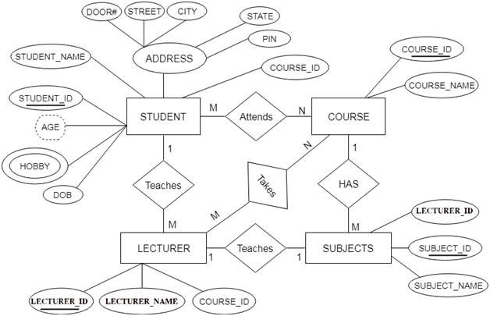
Using these rules, you can convert the ER diagram to tables and columns and assign the mapping between the tables. Table structure for the given ER diagram is as below:
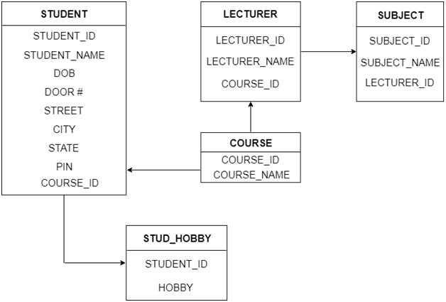
Figure: Table structure

Generalization
- Generalization is like a bottom-up approach in which two or more entities of lower level combine to form a higher level entity if they have some attributes in common.
- In generalization, an entity of a higher level can also combine with the entities of the lower level to form a further higher level entity.
- Generalization is more like subclass and superclass system, but the only difference is the approach. Generalization uses the bottom-up approach.
- In generalization, entities are combined to form a more generalized entity, i.e., subclasses are combined to make a superclass.
For example, Faculty and Student entities can be generalized and create a higher level entity Person.
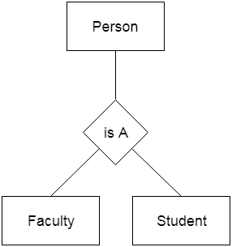

Specialization
- Specialization is a top-down approach, and it is opposite to Generalization. In specialization, one higher level entity can be broken down into two lower level entities.
- Specialization is used to identify the subset of an entity set that shares some distinguishing characteristics.
- Normally, the superclass is defined first, the subclass and its related attributes are defined next, and relationship set are then added.
For example: In an Employee management system, EMPLOYEE entity can be specialized as TESTER or DEVELOPER based on what role they play in the company.
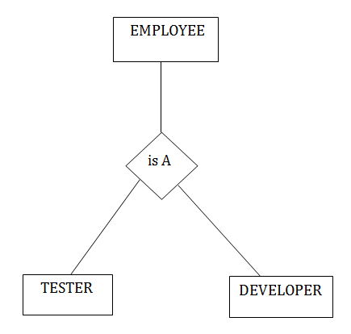

Aggregation
In aggregation, the relation between two entities is treated as a single entity. In aggregation, relationship with its corresponding entities is aggregated into a higher level entity.
For example: Center entity offers the Course entity act as a single entity in the relationship which is in a relationship with another entity visitor. In the real world, if a visitor visits a coaching center then he will never enquiry about the Course only or just about the Center instead he will ask the enquiry about both.
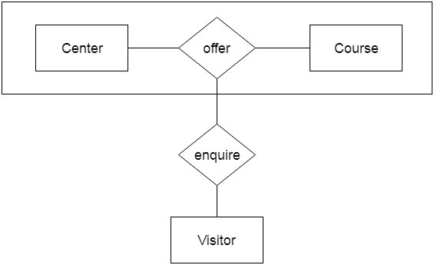

Relationship of higher degree
The degree of relationship can be defined as the number of occurrences in one entity that is associated with the number of occurrences in another entity.
There is the three degree of relationship:
- One-to-one (1:1)
- One-to-many (1:M)
- Many-to-many (M:N)

1. One-to-one
- In a one-to-one relationship, one occurrence of an entity relates to only one occurrence in another entity.
- A one-to-one relationship rarely exists in practice.
- For example: if an employee is allocated a company car then that car can only be driven by that employee.
- Therefore, employee and company car have a one-to-one relationship.
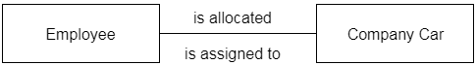

2. One-to-many
- In a one-to-many relationship, one occurrence in an entity relates to many occurrences in another entity.
- For example: An employee works in one department, but a department has many employees.
- Therefore, department and employee have a one-to-many relationship.
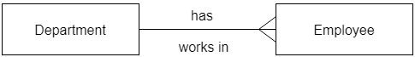

3. Many-to-many
- In a many-to-many relationship, many occurrences in an entity relate to many occurrences in another entity.
- Same as a one-to-one relationship, the many-to-many relationship rarely exists in practice.
- For example: At the same time, an employee can work on several projects, and a project has a team of many employees.
- Therefore, employee and project have a many-to-many relationship.
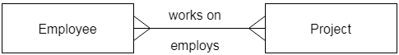
Views:
A view is nothing more than a SQL statement that is stored in the database with an associated name. A view is actually a composition of a table in the form of a predefined SQL query.
A view can contain all rows of a table or select rows from a table. A view can be created from one or many tables which depends on the written SQL query to create a view.
Views, which are a type of virtual tables allow users to do the following −
- Structure data in a way that users or classes of users find natural or intuitive.
- Restrict access to the data in such a way that a user can see and (sometimes) modify exactly what they need and no more.
- Summarize data from various tables which can be used to generate reports.
Data Dictionary:
A data dictionary contains metadata i.e data about the database. The data dictionary is very important as it contains information such as what is in the database, who is allowed to access it, where is the database physically stored etc. The users of the database normally don't interact with the data dictionary, it is only handled by the database administrators.
The data dictionary in general contains information about the following −
- Names of all the database tables and their schemas.
- Details about all the tables in the database, such as their owners, their security constraints, when they were created etc.
- Physical information about the tables such as where they are stored and how.
- Table constraints such as primary key attributes, foreign key information etc.
- Information about the database views that are visible.
This is a data dictionary describing a table that contains employee details.
Field Name | Data Type | Field Size for display | Description | Example
Employee  Number | Integer | 10 | Unique ID of each employee | 1645000001
Name | Text | 20 | Name of the employee | David Heston
Date of Birth | Date/Time | 10 | DOB of Employee | 08/03/1995
Phone Number | Integer | 10 | Phone number of employee | 6583648648
The different types of data dictionary are −

Active Data Dictionary
If the structure of the database or its specifications changes at any point of time, it should be reflected in the data dictionary. This is the responsibility of the database management system in which the data dictionary resides.
So, the data dictionary is automatically updated by the database management system when any changes are made in the database. This is known as an active data dictionary as it is self updating.

Passive Data Dictionary
This is not as useful or easy to handle as an active data dictionary. A passive data dictionary is maintained separately to the database whose contents are stored in the dictionary. That means that if the database is modified the database dictionary is not automatically updated as in the case of Active Data Dictionary.
So, the passive data dictionary has to be manually updated to match the database. This needs careful handling or else the database and data dictionary are out of sync.

Integrity Constraints
- Integrity constraints (condition) are a set of rules. It is used to maintain the quality of information.
- Integrity constraints ensure that the data insertion, updating, and other processes have to be performed in such a way that data integrity is not affected.
- Thus, integrity constraint is used to guard against accidental damage to the database.

Types of Integrity Constraint
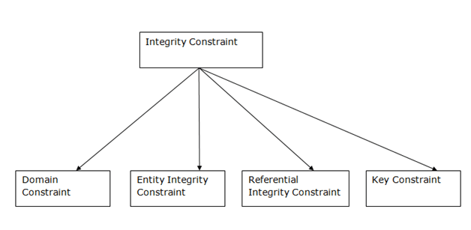

1. Domain constraints
- Domain constraints can be defined as the definition of a valid set of values for an attribute.
- The data type of domain includes string, character, integer, time, date, currency, etc. The value of the attribute must be available in the corresponding domain.
Example:
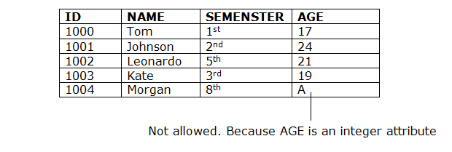

2. Entity integrity constraints
- The entity integrity constraint states that primary key value can't be null.
- This is because the primary key value is used to identify individual rows in relation and if the primary key has a null value, then we can't identify those rows.
- A table can contain a null value other than the primary key field.
Example:
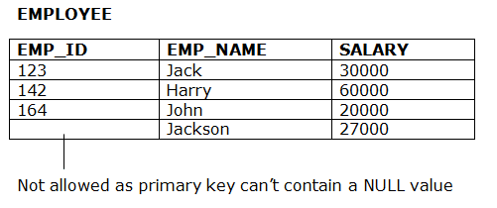

3. Referential Integrity Constraints
- A referential integrity constraint is specified between two tables.
- In the Referential integrity constraints, if a foreign key in Table 1 refers to the Primary Key of Table 2, then every value of the Foreign Key in Table 1 must be null or be available in Table 2.
Example:
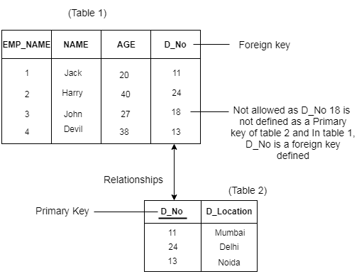

4. Key constraints
- Keys are the entity set that is used to identify an entity within its entity set uniquely.
- An entity set can have multiple keys, but out of which one key will be the primary key. A primary key can contain a unique and null value in the relational table.
Example:
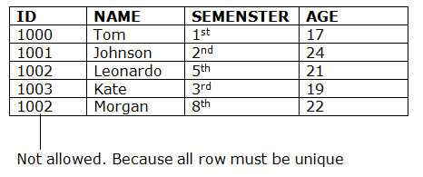

Relational Algebra
Relational algebra is a procedural query language. It gives a step by step process to obtain the result of the query. It uses operators to perform queries.

Types of Relational operation
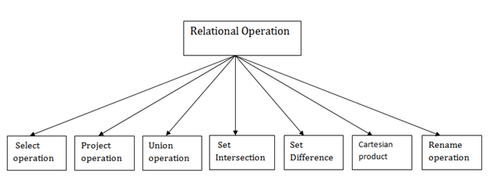

1. Select Operation:
- The select operation selects tuples that satisfy a given predicate.
- It is denoted by sigma (σ).
- Notation: σ p(r)
Where:
σ is used for selection prediction
r is used for relation
p is used as a propositional logic formula which may use connectors like: AND OR and NOT. These relational can use as relational operators like =, ≠, ≥, <, >, ≤.
For example: LOAN Relation
38.4M
879
OOPs Concepts in Java
BRANCH_NAME | LOAN_NO | AMOUNT
Downtown | L-17 | 1000
Redwood | L-23 | 2000
Perryride | L-15 | 1500
Downtown | L-14 | 1500
Mianus | L-13 | 500
Roundhill | L-11 | 900
Perryride | L-16 | 1300
Input:
- σ _{BRANCH_NAME="perryride" (LOAN)}
Output:
BRANCH_NAME | LOAN_NO | AMOUNT
Perryride | L-15 | 1500
Perryride | L-16 | 1300

2. Project Operation:
- This operation shows the list of those attributes that we wish to appear in the result. Rest of the attributes is eliminated from the table.
- It is denoted by ∏.
- Notation: ∏ A1, A2, An (r)
Where
A1, A2, A3 is used as an attribute name of relation r.
Example: CUSTOMER RELATION
NAME | STREET | CITY
Jones | Main | Harrison
Smith | North | Rye
Hays | Main | Harrison
Curry | North | Rye
Johnson | Alma | Brooklyn
Brooks | Senator | Brooklyn
Input:
- ∏ _{NAME, CITY (CUSTOMER)}
Output:
NAME | CITY
Jones | Harrison
Smith | Rye
Hays | Harrison
Curry | Rye
Johnson | Brooklyn
Brooks | Brooklyn

3. Union Operation:
- Suppose there are two tuples R and S. The union operation contains all the tuples that are either in R or S or both in R & S.
- It eliminates the duplicate tuples. It is denoted by ∪.
- Notation: R U S
A union operation must hold the following condition:
- R and S must have the attribute of the same number.
- Duplicate tuples are eliminated automatically.

Example:
DEPOSITOR RELATION
CUSTOMER_NAME | ACCOUNT_NO
Johnson | A-101
Smith | A-121
Mayes | A-321
Turner | A-176
Johnson | A-273
Jones | A-472
Lindsay | A-284
BORROW RELATION
CUSTOMER_NAME | LOAN_NO
Jones | L-17
Smith | L-23
Hayes | L-15
Jackson | L-14
Curry | L-93
Smith | L-11
Williams | L-17
CUSTOMER_NAME
Johnson
Smith
Hayes
Turner
Jones
Lindsay
Jackson
Curry
Williams
Mayes
Output:
∏ _{CUSTOMER_NAME (BORROW) ∪} ∏ _{CUSTOMER_NAME (DEPOSITOR)}

4. Set Intersection:
- Suppose there are two tuples R and S. The set intersection operation contains all tuples that are in both R & S.
- It is denoted by intersection ∩.
- Notation: R ∩ S
Example: Using the above DEPOSITOR table and BORROW table
Input:
- ∏ _{CUSTOMER_NAME (BORROW)} ∩ ∏ _{CUSTOMER_NAME (DEPOSITOR)}
Output:
CUSTOMER_NAME
Smith
Jones

5. Set Difference:
- Suppose there are two tuples R and S. The set intersection operation contains all tuples that are in R but not in S.
- It is denoted by intersection minus (-).
- Notation: R - S
Example: Using the above DEPOSITOR table and BORROW table
Input:
- ∏ _{CUSTOMER_NAME (BORROW)} - ∏ _{CUSTOMER_NAME (DEPOSITOR)}
Output:
CUSTOMER_NAME
Jackson
Hayes
Willians
Curry

6. Cartesian product
- The Cartesian product is used to combine each row in one table with each row in the other table. It is also known as a cross product.
- It is denoted by X.
- Notation: E X D

Example:
EMPLOYEE
EMP_ID | EMP_NAME | EMP_DEPT
1 | Smith | A
2 | Harry | C
3 | John | B
DEPARTMENT
DEPT_NO | DEPT_NAME
A | Marketing
B | Sales
C | Legal
Input:
- EMPLOYEE X DEPARTMENT
Output:
EMP_ID | EMP_NAME | EMP_DEPT | DEPT_NO | DEPT_NAME
1 | Smith | A | A | Marketing
1 | Smith | A | B | Sales
1 | Smith | A | C | Legal
2 | Harry | C | A | Marketing
2 | Harry | C | B | Sales
2 | Harry | C | C | Legal
3 | John | B | A | Marketing
3 | John | B | B | Sales
3 | John | B | C | Legal

7. Rename Operation:
The rename operation is used to rename the output relation. It is denoted by rho (ρ).
Example: We can use the rename operator to rename STUDENT relation to STUDENT1.
- ρ_{(STUDENT1, STUDENT)}

7. Division Operator (÷): Division operator A÷B or A/B can be applied if and only if:
- Attributes of B is proper subset of Attributes of A.
- The relation returned by division operator will have attributes = (All attributes of A – All Attributes of B)
- The relation returned by division operator will return those tuples from relation A which are associated to every B’s tuple.

Extended Operators in Relational Algebra

- Join
- Intersection
- Divide

Extended operators are those operators which can be derived from basic operators.

Join Operations:
A Join operation combines related tuples from different relations, if and only if a given join condition is satisfied. It is denoted by ⋈.

Example:
EMPLOYEE
EMP_CODE | EMP_NAME
101 | Stephan
102 | Jack
103 | Harry
SALARY
EMP_CODE | SALARY
101 | 50000
102 | 30000
103 | 25000
- Operation: (EMPLOYEE ⋈ SALARY)
Result:

EMP_CODE | EMP_NAME | SALARY
101 | Stephan | 50000
102 | Jack | 30000
103 | Harry | 25000

Types of Join operations:
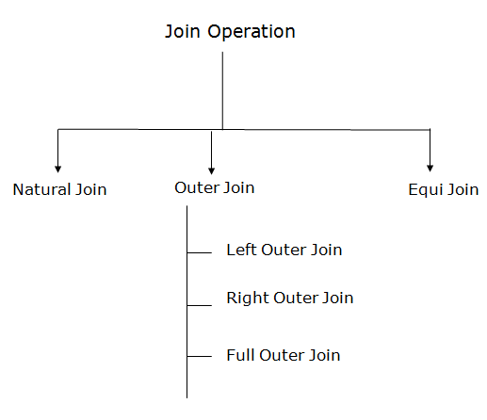

1. Natural Join:
- A natural join is the set of tuples of all combinations in R and S that are equal on their common attribute names.
- It is denoted by ⋈.
Example: Let's use the above EMPLOYEE table and SALARY table:
Input:
- ∏EMP_NAME, SALARY (EMPLOYEE ⋈ SALARY)
Output:
EMP_NAME | SALARY
Stephan | 50000
Jack | 30000
Harry | 25000

2. Outer Join:
The outer join operation is an extension of the join operation. It is used to deal with missing information.
Example:
EMPLOYEE
EMP_NAME | STREET | CITY
Ram | Civil line | Mumbai
Shyam | Park street | Kolkata
Ravi | M.G. Street | Delhi
Hari | Nehru nagar | Hyderabad
FACT_WORKERS
EMP_NAME | BRANCH | SALARY
Ram | Infosys | 10000
Shyam | Wipro | 20000
Kuber | HCL | 30000
Hari | TCS | 50000
Input:
- (EMPLOYEE ⋈ FACT_WORKERS)
Output:
EMP_NAME | STREET | CITY | BRANCH | SALARY
Ram | Civil line | Mumbai | Infosys | 10000
Shyam | Park street | Kolkata | Wipro | 20000
Hari | Nehru nagar | Hyderabad | TCS | 50000
An outer join is basically of three types:
- Left outer join
- Right outer join
- Full outer join

a. Left outer join:
- Left outer join contains the set of tuples of all combinations in R and S that are equal on their common attribute names.
- In the left outer join, tuples in R have no matching tuples in S.
- It is denoted by ⟕.
Example: Using the above EMPLOYEE table and FACT_WORKERS table
Input:
- EMPLOYEE ⟕ FACT_WORKERS

EMP_NAME | STREET | CITY | BRANCH | SALARY
Ram | Civil line | Mumbai | Infosys | 10000
Shyam | Park street | Kolkata | Wipro | 20000
Hari | Nehru street | Hyderabad | TCS | 50000
Ravi | M.G. Street | Delhi | NULL | NULL

b. Right outer join:
- Right outer join contains the set of tuples of all combinations in R and S that are equal on their common attribute names.
- In right outer join, tuples in S have no matching tuples in R.
- It is denoted by ⟖.
Example: Using the above EMPLOYEE table and FACT_WORKERS Relation
Input:
- EMPLOYEE ⟖ FACT_WORKERS
Output:
EMP_NAME | BRANCH | SALARY | STREET | CITY
Ram | Infosys | 10000 | Civil line | Mumbai
Shyam | Wipro | 20000 | Park street | Kolkata
Hari | TCS | 50000 | Nehru street | Hyderabad
Kuber | HCL | 30000 | NULL | NULL

c. Full outer join:
- Full outer join is like a left or right join except that it contains all rows from both tables.
- In full outer join, tuples in R that have no matching tuples in S and tuples in S that have no matching tuples in R in their common attribute name.
- It is denoted by ⟗.
Example: Using the above EMPLOYEE table and FACT_WORKERS table
Input:
- EMPLOYEE ⟗ FACT_WORKERS
Output:
EMP_NAME | STREET | CITY | BRANCH | SALARY
Ram | Civil line | Mumbai | Infosys | 10000
Shyam | Park street | Kolkata | Wipro | 20000
Hari | Nehru street | Hyderabad | TCS | 50000
Ravi | M.G. Street | Delhi | NULL | NULL
Kuber | NULL | NULL | HCL | 30000

3. Equi join:
It is also known as an inner join. It is the most common join. It is based on matched data as per the equality condition. The equi join uses the comparison operator(=).
Example:
CUSTOMER RELATION
CLASS_ID | NAME
1 | John
2 | Harry
3 | Jackson
PRODUCT
PRODUCT_ID | CITY
1 | Delhi
2 | Mumbai
3 | Noida
Input:
- CUSTOMER ⋈ PRODUCT
Output:
CLASS_ID | NAME | PRODUCT_ID | CITY
1 | John | 1 | Delhi
2 | Harry | 2 | Mumbai
3 | Harry | 3 | Noida

Relational Calculus
- Relational calculus is a non-procedural query language. In the non-procedural query language, the user is concerned with the details of how to obtain the end results.
- The relational calculus tells what to do but never explains how to do.

Types of Relational calculus:
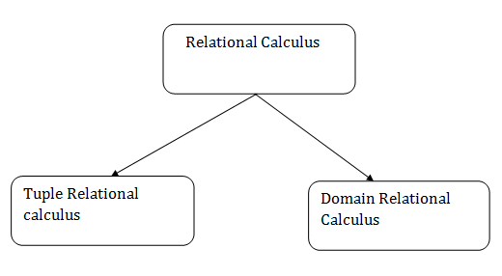

1. Tuple Relational Calculus (TRC)
- The tuple relational calculus is specified to select the tuples in a relation. In TRC, filtering variable uses the tuples of a relation.
- The result of the relation can have one or more tuples.
Notation:
- {T | P (T)} or {T | Condition (T)}
Where
T is the resulting tuples
P(T) is the condition used to fetch T.
For example:
To retrieve the names of all employees who earn more than $50,000 per year, we can use the following TRC query:
{ t | Employees(t) ∧ t.Salary > 50000 }

- { T.name | Author(T) AND T.article = 'database' }
OUTPUT: This query selects the tuples from the AUTHOR relation. It returns a tuple with 'name' from Author who has written an article on 'database'.
TRC (tuple relation calculus) can be quantified. In TRC, we can use Existential (∃) and Universal Quantifiers (∀).

Tuple Relational Calculus Examples
Table Customer
Customer name | Street | City
Saurabh | A7 | Patiala
Mehak | B6 | Jalandhar
Sumiti | D9 | Ludhiana
Ria | A5 | Patiala
Table Branch
Branch name | Branch City
ABC | Patiala
DEF | Ludhiana
GHI | Jalandhar
Table Account
Account number | Branch name | Balance
1111 | ABC | 50000
1112 | DEF | 10000
1113 | GHI | 9000
1114 | ABC | 7000
Table Loan
Loan number | Branch name | Amount
L33 | ABC | 10000
L35 | DEF | 15000
L49 | GHI | 9000
L98 | DEF | 65000
Table Borrower
Customer name | Loan number
Saurabh | L33
Mehak | L49
Ria | L98
Table Depositor
Customer name | Account number
Saurabh | 1111
Mehak | 1113
Suniti | 1114
Example 1: Find the loan number, branch, and amount of loans greater than or equal to 10000 amount.
{t| t ∈ loan ∧ t[amount]>=10000}
Resulting relation:
Loan number | Branch name | Amount
L33 | ABC | 10000
L35 | DEF | 15000
L98 | DEF | 65000
In the above query, t[amount] is known as a tuple variable.
Example 2: Find the loan number for each loan of an amount greater or equal to 10000.
{t| ∃ s ∈ loan(t[loan number] = s[loan number]
∧ s[amount]>=10000)}
Resulting relation:
Loan number
L33
L35
L98
Example 3: Find the names of all customers who have a loan and an account at the bank.
{t | ∃ s ∈ borrower( t[customer-name] = s[customer-name])
∧ ∃ u ∈ depositor( t[customer-name] = u[customer-name])}
Resulting relation:
Customer name
Saurabh
Mehak
Example 4: Find the names of all customers having a loan at the “ABC” branch.
{t | ∃ s ∈ borrower(t[customer-name] = s[customer-name]
∧ ∃ u ∈ loan(u[branch-name] = “ABC” ∧ u[loan-number] = s[loan-number]))}
Resulting relation:
Customer name
Saurabh

2. Domain Relational Calculus (DRC)
- The second form of relation is known as Domain relational calculus. In domain relational calculus, filtering variable uses the domain of attributes.
- Domain relational calculus uses the same operators as tuple calculus. It uses logical connectives ∧ (and), ∨ (or) and ┓ (not).
- It uses Existential (∃) and Universal Quantifiers (∀) to bind the variable.
Notation:
- { a1, a2, a3, ..., an | P (a1, a2, a3, ... ,an)}
Where
a1, a2 are attributes
P stands for formula built by inner attributes
For example:
- {< article, page, subject > | ∈ javatpoint ∧ subject = 'database'}
Output: This query will yield the article, page, and subject from the relational javatpoint, where the subject is a database.
Predicate Calculus Formula:
- Set of all comparison operators
- Set of connectives like and, or, not
- Set of quantifiers
Example:
Table-1: Customer
Customer name | Street | City
Debomit | Kadamtala | Alipurduar
Sayantan | Udaypur | Balurghat
Soumya | Nutanchati | Bankura
Ritu | Juhu | Mumbai
Table-2: Loan
Loan number | Branch name | Amount
L01 | Main | 200
L03 | Main | 150
L10 | Sub | 90
L08 | Main | 60
Table-3: Borrower
Customer name | Loan number
Ritu | L01
Debomit | L08
Soumya | L03
Query-1: Find the loan number, branch, amount of loans of greater than or equal to 100 amount.
{≺l, b, a≻ | ≺l, b, a≻ ∈ loan ∧ (a ≥ 100)}
Resulting relation:
Loan number | Branch name | Amount
L01 | Main | 200
L03 | Main | 150
Query-2: Find the loan number for each loan of an amount greater or equal to 150.
{≺l≻ | ∃ b, a (≺l, b, a≻ ∈ loan ∧ (a ≥ 150))}
Resulting relation:
Loan number
L01
L03
Query-3: Find the names of all customers having a loan at the “Main” branch and find the loan amount .

{≺c, a≻ | ∃ l (≺c, l≻ ∈ borrower ∧ ∃ b (≺l, b, a≻ ∈ loan ∧ (b = “Main”)))}
Resulting relation:
Customer Name | Amount
Ritu | 200
Debomit | 60
Soumya | 150
Note:
The domain variables those will be in resulting relation must appear before | within ≺ and ≻ and all the domain variables must appear in which order they are in original relation or table.

SQL
- SQL stands for Structured Query Language. It is used for storing and managing data in relational database management system (RDMS).
- It is a standard language for Relational Database System. It enables a user to create, read, update and delete relational databases and tables.
- All the RDBMS like MySQL, Informix, Oracle, MS Access and SQL Server use SQL as their standard database language.
- SQL allows users to query the database in a number of ways, using English-like statements.

Rules:
SQL follows the following rules:
- Structure query language is not case sensitive. Generally, keywords of SQL are written in uppercase.
- Statements of SQL are dependent on text lines. We can use a single SQL statement on one or multiple text line.
- Using the SQL statements, you can perform most of the actions in a database.
- SQL depends on tuple relational calculus and relational algebra.

SQL process:
- When an SQL command is executing for any RDBMS, then the system figure out the best way to carry out the request and the SQL engine determines that how to interpret the task.
- In the process, various components are included. These components can be optimization Engine, Query engine, Query dispatcher, classic, etc.
- All the non-SQL queries are handled by the classic query engine, but SQL query engine won't handle logical files.
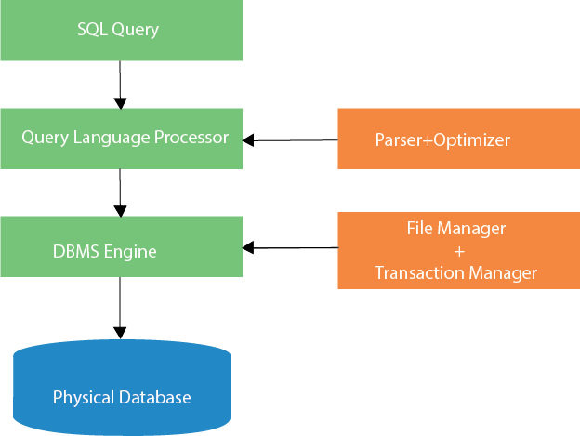

Characteristics of SQL
- SQL is easy to learn.
- SQL is used to access data from relational database management systems.
- SQL can execute queries against the database.
- SQL is used to describe the data.
- SQL is used to define the data in the database and manipulate it when needed.
- SQL is used to create and drop the database and table.
- SQL is used to create a view, stored procedure, function in a database.
- SQL allows users to set permissions on tables, procedures, and views.

Advantages of SQL
There are the following advantages of SQL:

High speed
Using the SQL queries, the user can quickly and efficiently retrieve a large amount of records from a database.

No coding needed
In the standard SQL, it is very easy to manage the database system. It doesn't require a substantial amount of code to manage the database system.

Well defined standards
Long established are used by the SQL databases that are being used by ISO and ANSI.

Portability
SQL can be used in laptop, PCs, server and even some mobile phones.

Interactive language
SQL is a domain language used to communicate with the database. It is also used to receive answers to the complex questions in seconds.

Multiple data view
Using the SQL language, the users can make different views of the database structure.

Data Definition Language
SQL uses the following set of commands to define database schema −

CREATE
Creates new databases, tables and views from RDBMS.
For example −
Create database tutorialspoint;
Create table article;
Create view for_students;

DROP
Drops commands, views, tables, and databases from RDBMS.
For example−
Drop object_type object_name;
Drop database tutorialspoint;
Drop table article;
Drop view for_students;

ALTER
Modifies database schema.
Alter object_type object_name parameters;
For example−
Alter table article add subject varchar;
This command adds an attribute in the relation article with the name subject of string type.

Data Manipulation Language
SQL is equipped with data manipulation language (DML). DML modifies the database instance by inserting, updating and deleting its data. DML is responsible for all forms data modification in a database. SQL contains the following set of commands in its DML section −
- SELECT/FROM/WHERE
- INSERT INTO/VALUES
- UPDATE/SET/WHERE
- DELETE FROM/WHERE
These basic constructs allow database programmers and users to enter data and information into the database and retrieve efficiently using a number of filter options.

SELECT/FROM/WHERE
- SELECT − This is one of the fundamental query command of SQL. It is similar to the projection operation of relational algebra. It selects the attributes based on the condition described by WHERE clause.
- FROM − This clause takes a relation name as an argument from which attributes are to be selected/projected. In case more than one relation names are given, this clause corresponds to Cartesian product.
- WHERE − This clause defines predicate or conditions, which must match in order to qualify the attributes to be projected.
For example −
Select author_name
From book_author
Where age > 50;
This command will yield the names of authors from the relation book_author whose age is greater than 50.

INSERT INTO/VALUES
This command is used for inserting values into the rows of a table (relation).
Syntax−
INSERT INTO table (column1 [, column2, column3 ... ]) VALUES (value1 [, value2, value3 ... ])
Or
INSERT INTO table VALUES (value1, [value2, ... ])
For example −
INSERT INTO tutorialspoint (Author, Subject) VALUES ("anonymous", "computers");

UPDATE/SET/WHERE
This command is used for updating or modifying the values of columns in a table (relation).
Syntax −
UPDATE table_name SET column_name = value [, column_name = value ...] [WHERE condition]
For example −
UPDATE tutorialspoint SET Author="webmaster" WHERE Author="anonymous";

DELETE/FROM/WHERE
This command is used for removing one or more rows from a table (relation).
Syntax −
DELETE FROM table_name [WHERE condition];
For example −
DELETE FROM tutorialspoints
WHERE Author="unknown";

What is Embedded SQL?
As we have seen in our previous tutorials, SQL is known as the Structured Query Language. It is the language that we use to perform operations and transactions on the databases.
When we talk about industry-level applications we need properly connected systems which could draw data from the database and present to the user. In such cases, the embedded SQL comes to our rescue.
We embed SQL queries into high-level languages such that they can easily perform the logic part of our analysis.
Some of the prominent examples of languages with which we embed SQL are as follows:
- C++
- Java
- Python etc.

Why do we need Embedded SQL?
Embedded SQL gives us the freedom to use databases as and when required. Once the application we develop goes into the production mode several things need to be taken care of.
We need to take care of a thousand things out of which one major aspect is the problem of authorization and fetching and feeding of data into/from the database.
With the help of the embedding of queries, we can easily use the database without creating any bulky code. With the embedded SQL, we can create API’s which can easily fetch and feed data as and when required.

How to Embed SQL in High-Level Languages?
For using embedded SQL, we need some tools in each high-level language. In some cases, we have inbuilt libraries which provide us with the basic building block.
While in some cases we need to import or use some packages to perform the desired tasks.
For example, in Java, we need a connection class. We first create a connection by using the connection class and further we open the connection bypassing the required parameters to connect with the database.

Advantages of Embedded SQL
Some of the advantages of using SQL embedded in high-level languages are as follows:
- Helps to access databases from anywhere.
- Allows integrating authentication service for large scale applications.
- Provides extra security to database transactions.
- Avoids logical errors while performing transactions on our database.
- Makes it easy to integrate the frontend and the backend of our application.

SQL JOIN
As the name shows, JOIN means to combine something. In case of SQL, JOIN means "to combine two or more tables".
In SQL, JOIN clause is used to combine the records from two or more tables in a database.

Types of SQL JOIN
- INNER JOIN
- LEFT JOIN
- RIGHT JOIN
- FULL JOIN

Sample Table
EMPLOYEE
EMP_ID | EMP_NAME | CITY | SALARY | AGE
1 | Angelina | Chicago | 200000 | 30
2 | Robert | Austin | 300000 | 26
3 | Christian | Denver | 100000 | 42
4 | Kristen | Washington | 500000 | 29
5 | Russell | Los angels | 200000 | 36
6 | Marry | Canada | 600000 | 48
PROJECT
PROJECT_NO | EMP_ID | DEPARTMENT
101 | 1 | Testing
102 | 2 | Development
103 | 3 | Designing
104 | 4 | Development

1. INNER JOIN
In SQL, INNER JOIN selects records that have matching values in both tables as long as the condition is satisfied. It returns the combination of all rows from both the tables where the condition satisfies.
Syntax
- SELECT table1.column1, table1.column2, table2.column1,....
- FROM table1
- INNER JOIN table2
- ON table1.matching_column = table2.matching_column;
Query
- SELECT EMPLOYEE.EMP_NAME, PROJECT.DEPARTMENT
- FROM EMPLOYEE
- INNER JOIN PROJECT
- ON PROJECT.EMP_ID = EMPLOYEE.EMP_ID;
Output
EMP_NAME | DEPARTMENT
Angelina | Testing
Robert | Development
Christian | Designing
Kristen | Development

2. LEFT JOIN
The SQL left join returns all the values from left table and the matching values from the right table. If there is no matching join value, it will return NULL.
Syntax
- SELECT table1.column1, table1.column2, table2.column1,....
- FROM table1
- LEFT JOIN table2
- ON table1.matching_column = table2.matching_column;
Query
- SELECT EMPLOYEE.EMP_NAME, PROJECT.DEPARTMENT
- FROM EMPLOYEE
- LEFT JOIN PROJECT
- ON PROJECT.EMP_ID = EMPLOYEE.EMP_ID;
Output
EMP_NAME | DEPARTMENT
Angelina | Testing
Robert | Development
Christian | Designing
Kristen | Development
Russell | NULL
Marry | NULL

3. RIGHT JOIN
In SQL, RIGHT JOIN returns all the values from the values from the rows of right table and the matched values from the left table. If there is no matching in both tables, it will return NULL.
Syntax
- SELECT table1.column1, table1.column2, table2.column1,....
- FROM table1
- RIGHT JOIN table2
- ON table1.matching_column = table2.matching_column;
Query
- SELECT EMPLOYEE.EMP_NAME, PROJECT.DEPARTMENT
- FROM EMPLOYEE
- RIGHT JOIN PROJECT
- ON PROJECT.EMP_ID = EMPLOYEE.EMP_ID;
Output
EMP_NAME | DEPARTMENT
Angelina | Testing
Robert | Development
Christian | Designing
Kristen | Development

4. FULL JOIN
In SQL, FULL JOIN is the result of a combination of both left and right outer join. Join tables have all the records from both tables. It puts NULL on the place of matches not found.
Syntax
- SELECT table1.column1, table1.column2, table2.column1,....
- FROM table1
- FULL JOIN table2
- ON table1.matching_column = table2.matching_column;
Query
- SELECT EMPLOYEE.EMP_NAME, PROJECT.DEPARTMENT
- FROM EMPLOYEE
- FULL JOIN PROJECT
- ON PROJECT.EMP_ID = EMPLOYEE.EMP_ID;
Output
EMP_NAME | DEPARTMENT
Angelina | Testing
Robert | Development
Christian | Designing
Kristen | Development
Russell | NULL
Marry | NULL

SQL Trigger
Trigger is invoked by Oracle engine automatically whenever a specified event occurs. Trigger is stored into database and invoked repeatedly, when specific condition match.
Triggers are stored programs, which are automatically executed or fired when some event occurs.
Triggers are written to be executed in response to any of the following events.
- A database manipulation (DML) statement (DELETE, INSERT, or UPDATE).
- A database definition (DDL) statement (CREATE, ALTER, or DROP).
- A database operation (SERVERERROR, LOGON, LOGOFF, STARTUP, or SHUTDOWN).
Triggers could be defined on the table, view, schema, or database with which the event is associated.

Advantages of Triggers
These are the following advantages of Triggers:
- Trigger generates some derived column values automatically
- Enforces referential integrity
- Event logging and storing information on table access
- Auditing
- Synchronous replication of tables
- Imposing security authorizations
- Preventing invalid transactions

Creating a trigger:
Syntax for creating trigger:
- CREATE [OR REPLACE ] TRIGGER trigger_name
- {BEFORE | AFTER | INSTEAD OF }
- {INSERT [OR] | UPDATE [OR] | DELETE}
- [OF col_name]
- ON table_name
- [REFERENCING OLD AS o NEW AS n]
- [FOR EACH ROW]
- WHEN (condition)
- DECLARE
- Declaration-statements
- BEGIN
- Executable-statements
- EXCEPTION
- Exception-handling-statements
- END;
Here,
- CREATE [OR REPLACE] TRIGGER trigger_name: It creates or replaces an existing trigger with the trigger_name.
- {BEFORE | AFTER | INSTEAD OF} : This specifies when the trigger would be executed. The INSTEAD OF clause is used for creating trigger on a view.
- {INSERT [OR] | UPDATE [OR] | DELETE}: This specifies the DML operation.
- [OF col_name]: This specifies the column name that would be updated.
- [ON table_name]: This specifies the name of the table associated with the trigger.
- [REFERENCING OLD AS o NEW AS n]: This allows you to refer new and old values for various DML statements, like INSERT, UPDATE, and DELETE.
- [FOR EACH ROW]: This specifies a row level trigger, i.e., the trigger would be executed for each row being affected. Otherwise the trigger will execute just once when the SQL statement is executed, which is called a table level trigger.
- WHEN (condition): This provides a condition for rows for which the trigger would fire. This clause is valid only for row level triggers.

PL/SQL Trigger Example
Let's take a simple example to demonstrate the trigger. In this example, we are using the following CUSTOMERS table:
Create table and have records:
ID | NAME | AGE | ADDRESS | SALARY
1 | Ramesh | 23 | Allahabad | 20000
2 | Suresh | 22 | Kanpur | 22000
3 | Mahesh | 24 | Ghaziabad | 24000
4 | Chandan | 25 | Noida | 26000
5 | Alex | 21 | Paris | 28000
6 | Sunita | 20 | Delhi | 30000
Create trigger:
Let's take a program to create a row level trigger for the CUSTOMERS table that would fire for INSERT or UPDATE or DELETE operations performed on the CUSTOMERS table. This trigger will display the salary difference between the old values and new values:
- CREATE OR REPLACE TRIGGER display_salary_changes
- BEFORE DELETE OR INSERT OR UPDATE ON customers
- FOR EACH ROW
- WHEN (NEW.ID > 0)
- DECLARE
- sal_diff number;
- BEGIN
- sal_diff := :NEW.salary - :OLD.salary;
- dbms_output.put_line('Old salary: ' || :OLD.salary);
- dbms_output.put_line('New salary: ' || :NEW.salary);
- dbms_output.put_line('Salary difference: ' || sal_diff);
- END;
- /
After the execution of the above code at SQL Prompt, it produces the following result.
Trigger created.
Check the salary difference by procedure:
Use the following code to get the old salary, new salary and salary difference after the trigger created.
- DECLARE
- total_rows number(2);
- BEGIN
- UPDATE customers
- SET salary = salary + 5000;
- IF sql%notfound THEN
- dbms_output.put_line('no customers updated');
- ELSIF sql%found THEN
- total_rows := sql%rowcount;
- dbms_output.put_line( total_rows || ' customers updated ');
- END IF;
- END;
- /
Output:
Old salary: 20000
New salary: 25000
Salary difference: 5000
Old salary: 22000
New salary: 27000
Salary difference: 5000
Old salary: 24000
New salary: 29000
Salary difference: 5000
Old salary: 26000
New salary: 31000
Salary difference: 5000
Old salary: 28000
New salary: 33000
Salary difference: 5000
Old salary: 30000
New salary: 35000
Salary difference: 5000
6 customers updated
Note: As many times you executed this code, the old and new both salary is incremented by 5000 and hence the salary difference is always 5000.
After the execution of above code again, you will get the following result.
Old salary: 25000
New salary: 30000
Salary difference: 5000
Old salary: 27000
New salary: 32000
Salary difference: 5000
Old salary: 29000
New salary: 34000
Salary difference: 5000
Old salary: 31000
New salary: 36000
Salary difference: 5000
Old salary: 33000
New salary: 38000
Salary difference: 5000
Old salary: 35000
New salary: 40000
Salary difference: 5000
6 customers updated

Important Points
Following are the two very important point and should be noted carefully.
- OLD and NEW references are used for record level triggers these are not avialable for table level triggers.
- If you want to query the table in the same trigger, then you should use the AFTER keyword, because triggers can query the table or change it again only after the initial changes are applied and the table is back in a consistent state.

SQL CREATE VIEW Statement
In SQL, a view is a virtual table based on the result-set of an SQL statement.
A view contains rows and columns, just like a real table. The fields in a view are fields from one or more real tables in the database.
You can add SQL statements and functions to a view and present the data as if the data were coming from one single table.
A view is created with the CREATE VIEW statement.

CREATE VIEW Syntax
CREATE VIEW view_name AS
SELECT column1, column2, ...
FROM table_name
WHERE condition;
Note: A view always shows up-to-date data! The database engine recreates the view, every time a user queries it.

NESTED Query
A Subquery or Inner query or a Nested query is a query within another SQL query and embedded within the WHERE clause.
A subquery is used to return data that will be used in the main query as a condition to further restrict the data to be retrieved.
Subqueries can be used with the SELECT, INSERT, UPDATE, and DELETE statements along with the operators like =, <, >, >=, <=, IN, BETWEEN, etc.
There are a few rules that subqueries must follow −
- Subqueries must be enclosed within parentheses.
- A subquery can have only one column in the SELECT clause, unless multiple columns are in the main query for the subquery to compare its selected columns.
- An ORDER BY command cannot be used in a subquery, although the main query can use an ORDER BY. The GROUP BY command can be used to perform the same function as the ORDER BY in a subquery.
- Subqueries that return more than one row can only be used with multiple value operators such as the IN operator.
- The SELECT list cannot include any references to values that evaluate to a BLOB, ARRAY, CLOB, or NCLOB.
- A subquery cannot be immediately enclosed in a set function.
- The BETWEEN operator cannot be used with a subquery. However, the BETWEEN operator can be used within the subquery.

Subqueries with the SELECT Statement
Subqueries are most frequently used with the SELECT statement. The basic syntax is as follows −
SELECT column_name [, column_name ]
FROM table1 [, table2 ]
WHERE column_name OPERATOR
(SELECT column_name [, column_name ]
FROM table1 [, table2 ]
[WHERE])

Example
Consider the CUSTOMERS table having the following records −
+----+----------+-----+-----------+----------+
| ID | NAME | AGE | ADDRESS | SALARY |
+----+----------+-----+-----------+----------+
| 1 | Ramesh | 35 | Ahmedabad | 2000.00 |
| 2 | Khilan | 25 | Delhi | 1500.00 |
| 3 | kaushik | 23 | Kota | 2000.00 |
| 4 | Chaitali | 25 | Mumbai | 6500.00 |
| 5 | Hardik | 27 | Bhopal | 8500.00 |
| 6 | Komal | 22 | MP | 4500.00 |
| 7 | Muffy | 24 | Indore | 10000.00 |
+----+----------+-----+-----------+----------+
Now, let us check the following subquery with a SELECT statement.
SQL> SELECT *
FROM CUSTOMERS
WHERE ID IN (SELECT ID
FROM CUSTOMERS
WHERE SALARY > 4500) ;
This would produce the following result.
+----+----------+-----+---------+----------+
| ID | NAME | AGE | ADDRESS | SALARY |
+----+----------+-----+---------+----------+
| 4 | Chaitali | 25 | Mumbai | 6500.00 |
| 5 | Hardik | 27 | Bhopal | 8500.00 |
| 7 | Muffy | 24 | Indore | 10000.00 |
+----+----------+-----+---------+----------+

Subqueries with the INSERT Statement
Subqueries also can be used with INSERT statements. The INSERT statement uses the data returned from the subquery to insert into another table. The selected data in the subquery can be modified with any of the character, date or number functions.
The basic syntax is as follows.
INSERT INTO table_name [ (column1 [, column2 ]) ]
SELECT [ *|column1 [, column2 ]
FROM table1 [, table2 ]
[ WHERE VALUE OPERATOR ]

Example
Consider a table CUSTOMERS_BKP with similar structure as CUSTOMERS table. Now to copy the complete CUSTOMERS table into the CUSTOMERS_BKP table, you can use the following syntax.
SQL> INSERT INTO CUSTOMERS_BKP
SELECT * FROM CUSTOMERS
WHERE ID IN (SELECT ID
FROM CUSTOMERS) ;

Subqueries with the UPDATE Statement
The subquery can be used in conjunction with the UPDATE statement. Either single or multiple columns in a table can be updated when using a subquery with the UPDATE statement.
The basic syntax is as follows.
UPDATE table
SET column_name = new_value
[ WHERE OPERATOR [ VALUE ]
(SELECT COLUMN_NAME
FROM TABLE_NAME)
[ WHERE) ]

Example
Assuming, we have CUSTOMERS_BKP table available which is backup of CUSTOMERS table. The following example updates SALARY by 0.25 times in the CUSTOMERS table for all the customers whose AGE is greater than or equal to 27.
SQL> UPDATE CUSTOMERS
SET SALARY = SALARY * 0.25
WHERE AGE IN (SELECT AGE FROM CUSTOMERS_BKP
WHERE AGE >= 27 );
This would impact two rows and finally CUSTOMERS table would have the following records.
+----+----------+-----+-----------+----------+
| ID | NAME | AGE | ADDRESS | SALARY |
+----+----------+-----+-----------+----------+
| 1 | Ramesh | 35 | Ahmedabad | 125.00 |
| 2 | Khilan | 25 | Delhi | 1500.00 |
| 3 | kaushik | 23 | Kota | 2000.00 |
| 4 | Chaitali | 25 | Mumbai | 6500.00 |
| 5 | Hardik | 27 | Bhopal | 2125.00 |
| 6 | Komal | 22 | MP | 4500.00 |
| 7 | Muffy | 24 | Indore | 10000.00 |
+----+----------+-----+-----------+----------+

Subqueries with the DELETE Statement
The subquery can be used in conjunction with the DELETE statement like with any other statements mentioned above.
The basic syntax is as follows.
DELETE FROM TABLE_NAME
[ WHERE OPERATOR [ VALUE ]
(SELECT COLUMN_NAME
FROM TABLE_NAME)
[ WHERE) ]

Example
Assuming, we have a CUSTOMERS_BKP table available which is a backup of the CUSTOMERS table. The following example deletes the records from the CUSTOMERS table for all the customers whose AGE is greater than or equal to 27.
SQL> DELETE FROM CUSTOMERS
WHERE AGE IN (SELECT AGE FROM CUSTOMERS_BKP
WHERE AGE >= 27 );
This would impact two rows and finally the CUSTOMERS table would have the following records.
+----+----------+-----+---------+----------+
| ID | NAME | AGE | ADDRESS | SALARY |
+----+----------+-----+---------+----------+
| 2 | Khilan | 25 | Delhi | 1500.00 |
| 3 | kaushik | 23 | Kota | 2000.00 |
| 4 | Chaitali | 25 | Mumbai | 6500.00 |
| 6 | Komal | 22 | MP | 4500.00 |
| 7 | Muffy | 24 | Indore | 10000.00 |
+----+----------+-----+---------+----------+

JOINS

The SQL Joins clause is used to combine records from two or more tables in a database. A JOIN is a means for combining fields from two tables by using values common to each.
Consider the following two tables −
Table 1 − CUSTOMERS Table
+----+----------+-----+-----------+----------+
| ID | NAME | AGE | ADDRESS | SALARY |
+----+----------+-----+-----------+----------+
| 1 | Ramesh | 32 | Ahmedabad | 2000.00 |
| 2 | Khilan | 25 | Delhi | 1500.00 |
| 3 | kaushik | 23 | Kota | 2000.00 |
| 4 | Chaitali | 25 | Mumbai | 6500.00 |
| 5 | Hardik | 27 | Bhopal | 8500.00 |
| 6 | Komal | 22 | MP | 4500.00 |
| 7 | Muffy | 24 | Indore | 10000.00 |
+----+----------+-----+-----------+----------+
Table 2 − ORDERS Table
+-----+---------------------+-------------+--------+
|OID | DATE | CUSTOMER_ID | AMOUNT |
+-----+---------------------+-------------+--------+
| 102 | 2009-10-08 00:00:00 | 3 | 3000 |
| 100 | 2009-10-08 00:00:00 | 3 | 1500 |
| 101 | 2009-11-20 00:00:00 | 2 | 1560 |
| 103 | 2008-05-20 00:00:00 | 4 | 2060 |
+-----+---------------------+-------------+--------+
Now, let us join these two tables in our SELECT statement as shown below.
SQL> SELECT ID, NAME, AGE, AMOUNT
FROM CUSTOMERS, ORDERS
WHERE CUSTOMERS.ID = ORDERS.CUSTOMER_ID;
This would produce the following result.
+----+----------+-----+--------+
| ID | NAME | AGE | AMOUNT |
+----+----------+-----+--------+
| 3 | kaushik | 23 | 3000 |
| 3 | kaushik | 23 | 1500 |
| 2 | Khilan | 25 | 1560 |
| 4 | Chaitali | 25 | 2060 |
+----+----------+-----+--------+
Here, it is noticeable that the join is performed in the WHERE clause. Several operators can be used to join tables, such as =, <, >, <>, <=, >=, !=, BETWEEN, LIKE, and NOT; they can all be used to join tables. However, the most common operator is the equal to symbol.
There are different types of joins available in SQL −
- INNER JOIN − returns rows when there is a match in both tables.
- LEFT JOIN − returns all rows from the left table, even if there are no matches in the right table.
- RIGHT JOIN − returns all rows from the right table, even if there are no matches in the left table.
- FULL JOIN − returns rows when there is a match in one of the tables.
- SELF JOIN − is used to join a table to itself as if the table were two tables, temporarily renaming at least one table in the SQL statement.
- CARTESIAN JOIN − returns the Cartesian product of the sets of records from the two or more joined tables.
Let us now discuss each of these joins in detail.

